15.73: The plank is oscillating in its fundamental mode, so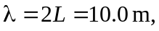with a frequency of 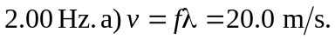 b) The plank would be its first overtone, with twice the frequency, or 